Understanding 3-Tier Architecture
A Simple Explanation Using a Therapy-Based Platform

1. Why Do We Need an Architecture?
Imagine a therapy platform where:
- Patients book sessions
- Therapists manage schedules
- Admins run the platform
If everything is built in one place, the system becomes:
- Hard to change
- Easy to break
- Difficult to scale
So we divide the system into three clear parts, each with one main job.
This is called 3-Tier Architecture.

2. What Is 3-Tier Architecture? (In One Line)
3-Tier Architecture means:
Separating what users see, how the system thinks, and where data is stored.
The three tiers are:
- Presentation Tier (What users see)
- Application Tier (How decisions are made)
- Data Tier (Where information lives)

3. Presentation Tier
“The Face of the System”
This is the part users interact with.

Examples in Our Therapy Platform
- Login screen
- Book therapy session page
- Therapist dashboard
- Admin panels

Technology Example
- Next.js and Node.js

Simple Explanation
Think of this tier like a reception desk:
- Users talk to it
- It shows information
- It does not make decisions
- It does not store data permanently
It only asks questions and shows answers.

4. Application Tier
“The Brain of the System”
This tier decides what should happen.

Examples in Our Therapy Platform
- Can this user book a session?
- Is the therapist available?
- Should payment be accepted?
- What data should be shown?

Technology Example
- Python services
- Node.js backend APIs

Simple Explanation
This is like the therapist and office staff behind the desk:
- They understand rules
- They make decisions
- They talk to the database
- They send proper responses back
All logic lives here.

5. Data Tier
“The Memory of the System”
This tier stores information safely.

Examples in Our Therapy Platform
- User details
- Appointment history
- Therapy session records
- Subscription data

Technology Example
- PostgreSQL database

Simple Explanation
This is the filing cabinet:
- It only stores data
- It does not talk to users directly
- It does not make decisions
Only the Application Tier can access it.

6. How the Three Tiers Work Together
A simple booking flow:
- User clicks “Book Session” (Presentation Tier)
- Request goes to the Application Tier
- Application checks rules and availability
- Data is read or saved in Data Tier
- Response goes back to the user
Each tier does only its own job.
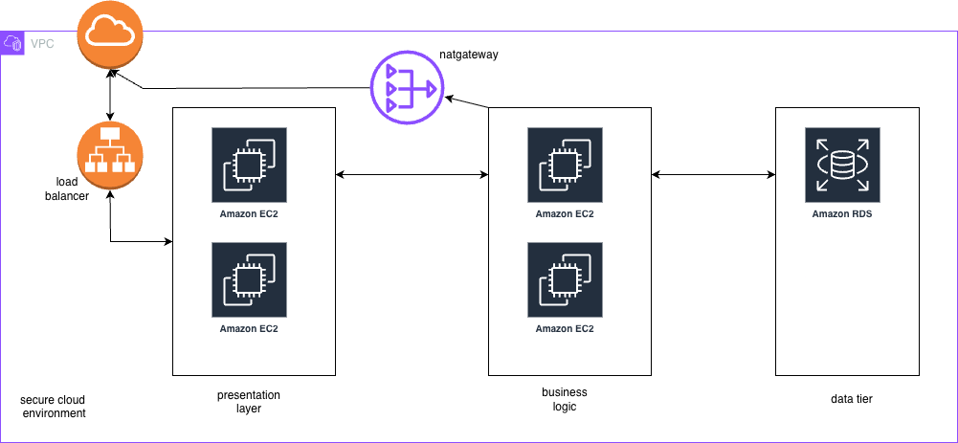

7. Why This Separation Matters
For people using the platform:
- Faster experience
- Fewer crashes
- Better reliability
For the business:
- Easy to add new features
- System can grow with more users
- Problems are easier to fix
For teams:
- Designers focus on UI
- Developers focus on logic
- DevOps ensures everything runs smoothly

8. Simple Analogy to Remember
- Presentation Tier: Front desk
- Application Tier: Office staff
- Data Tier: Filing room
Each has a role.
None tries to do everything.

9. Conclusion
The 3-Tier Architecture helps build systems that are:
- Easy to understand
- Easy to maintain
- Easy to scale
For a therapy-based PaaS platform, this structure keeps the system clean, secure, and reliable while supporting growth and change.

